Development of a Web-Based Student Clearance
Management System

An
Undergraduate
Research Paper Presented
to The Faculty of the College of Computer
Science in Christ the King College de Maranding, Inc.

In Partial
Fulfillment of the Requirement for Software
Engineering 2 Bachelor of Science in Computer Science

by
FRANCIS H. VILLARIN
HALRMYR JAY A. AGUILAR
LIEZA MAE D. TRAZARES

August 2026
Development of a Web-Based Student Clearance
Management System



FRANCIS H. VILLARIN
HALRMYR JAY A. AGUILAR
LIEZA MAE D. TRAZARES

BACHELOR OF SCIENCE IN COMPUTER SCIENCE

September 21

Chapter 1
PROBLEM AND ITS SCOPE
Introduction
Christ the King College de Maranding Inc. (CKCM) is an educational institution that provides academic services to students and supports their educational needs through various school offices and personnel. As part of its administrative operations, students need to complete clearance requirements that involve different offices before they can complete certain school processes, such as enrollment, graduation, transfer, or requesting official documents. Managing these requirements efficiently is important to ensure that students and school personnel can complete the clearance process in an organized and timely manner.
Technology has become an important part of education, helping schools improve their services and daily operations. Despite these improvements, many schools still use manual processes for student clearance. Students are required to visit different offices, such as the Library, Guidance Office, Accounting Office, Registrar, and other concerned offices, to obtain signatures or approvals before they can enroll, graduate, transfer, or request official documents. This process often takes a long time because students need to wait in line at each office. Paper forms may also be lost or damaged, making it difficult to track the progress of a student's clearance. As a result, both students and school personnel experience delays, inconvenience, and increased workload.
This study implies that the development of a Web-Based Student Clearance Management System can improve the existing clearance process by replacing the manual paper-based method with a digital system. The proposed system will allow students to submit their clearance requests online and monitor their clearance status through a web browser. School offices will be able to review requests, approve or reject applications, and update student records using a centralized database. The system is expected to reduce paperwork, minimize human errors, improve record management, shorten processing time, and provide a more convenient and efficient clearance process for both students and school personnel.
Several studies have shown that web-based information systems improve school operations by making administrative processes faster and more organized.
According to the study of David et al. (2026) developed a secured web-based student clearance system that reduced paperwork, improved data security, and increased the efficiency of processing student clearances. Their findings showed that using an online clearance system helped school personnel manage student records more effectively while providing faster services to students.
According to Grepon et al. (2021), developed an electronic school management information system that improved school operations by organizing records, reducing manual work, and providing easier access to information. Their study found that the system achieved high ratings in functionality, usability, and reliability. These studies support the development of a Web-Based Student Clearance Management System because they demonstrate that digital systems can improve administrative services, reduce processing time, and provide better record management in educational institutions.
Another related study by (Hasan et al., 2023) developed a Digital Student Clearance System for Soran University. The researchers found that the traditional paper-based clearance process caused delays, increased paperwork, and made it difficult to monitor the progress of student clearances. To solve these problems, they designed a digital clearance system that allowed students to submit requests online while enabling school offices to review and approve clearances through a centralized platform. The study concluded that the system improved processing speed, reduced paperwork, enhanced record management, and increased user satisfaction. These findings support the present study because they show that a web-based clearance system can improve the efficiency, accuracy, and reliability of the student clearance process.
The primary objective of this study, in titled Development of a Web-Based Student Clearance Management System, is to design and develop a web-based system that will improve the student clearance process. Specifically, the system aims to allow students to submit clearance requests online, monitor the status of their applications, and receive updates in real time. It also aims to provide school offices with a centralized platform for reviewing, approving, and managing student clearance requests efficiently. Ultimately, the study seeks to improve the quality, accuracy, and efficiency of the school's clearance services.
This study will be conducted during the Academic Year 2026–2027. During this period, the researchers will gather the necessary information, analyze the existing clearance process, design and develop the proposed system, conduct system testing, and evaluate its performance. The timeframe will provide sufficient opportunity to ensure that the developed system is functional, reliable, and meets the needs of students and school personnel before its final evaluation.
The researchers will conduct this study by collecting information from students and authorized school offices involved in the clearance process. The gathered data will be used to identify the existing problems and serve as the basis for developing the proposed system. As Bachelor of Science in Computer Science students, the researchers have acquired knowledge and skills in systems analysis and design, web development, database management, and software engineering. These competencies will guide them in developing a reliable and effective Web-Based Student Clearance Management System. By applying appropriate research methods and modern web technologies, the researchers aim to provide a practical solution that will improve the school's clearance process and contribute to the digital transformation of school administrative services.

Theoretical Framework
Theories are presented in this chapter to provide the theoretical foundation of the study. The researchers will use these theories to support the development of the Web-Based Student Clearance Management System. These theories include the Technology Acceptance Model (TAM) by (O’dea et al., 2025), the Digital Transformation Theory by (Paul et al., 2024) and the Information Systems Success Model by (Al-Kofahi et al., 2025)
According to the study of (O’dea et al. 2025), technology Acceptance Model (TAM) explains that users are more likely to accept and use a system if they believe it is easy to use and useful. This theory focuses on two important factors: perceived usefulness and perceived ease of use. In this study, the Web-Based Student Clearance Management System is designed with a simple interface that allows students and school offices to complete the clearance process quickly and easily. By making the system user-friendly, students and staff are more likely to use and accept it.
According to (Paul et al., 2024), the Digital Transformation Theory explains how organizations can improve their processes and services through the use of digital technologies. The use of digital systems can help organizations increase efficiency, improve communication, reduce paperwork, and provide faster services. This theory supports the development of the Web-Based Student Clearance Management System because it transforms the traditional paper-based clearance process into a digital and online process. Through the system, students and school personnel can manage clearance requirements, monitor clearance status, and process records more efficiently.
According to (Al-Kofahi et al., 2025) the Information Systems Success Model states that the success of an information system depends on factors such as system quality, information quality, service quality, user satisfaction, and system use. A system that is reliable, easy to use, and provides accurate information is more likely to satisfy its users and improve organizational performance. In this study, the model supports the evaluation of the Web-Based Student Clearance Management System by ensuring that it meets software quality standards and provides efficient services to students, school offices, and administrators.
Conceptual Framework
This framework aims to present the systematic flow of the study titled Development of a Web-Based Student Clearance Management System. As shown in Figure 1, the conceptual framework illustrates the overall process of the proposed system. The inputs include user information, such as student and school personnel accounts, student clearance records, and the responsibilities of authorized offices, including the Library, Guidance Office, Accounting Office, and Registrar. The system also includes functional features such as user authentication, online clearance request submission, approval and rejection of requests, clearance status tracking, notifications, and report generation. These inputs provide the necessary information and resources for the development of the system and help identify the requirements needed to support the clearance process.
The development of the proposed system follows the Waterfall Model, which consists of the phases of Process, Analysis, System Design, Implementation, Testing, Deployment and Maintenance. Each phase is completed before proceeding to the next to ensure that the system is carefully planned, developed, tested, and maintained. The Process and Analysis phases focus on identifying the existing problems and gathering the requirements of the intended users. The System Design phase establishes the structure, interface, database, and workflow of the system. Implementation transforms the approved design into a functional system, while Testing ensures that the system operates correctly and meets the identified requirements. Deployment introduces the system for actual use, while Maintenance ensures its continued functionality and improvement.
The expected output of the study is a fully functional Web-Based Student Clearance Management System that provides a faster, more organized, and more efficient way of processing student clearances. The system centralizes clearance records, simplifies communication between students and school offices, reduces paperwork, minimizes processing delays, and improves the overall management of the student clearance process. Through this framework, the researchers ensure that the proposed system is developed systematically and effectively meets the needs of both students and school personnel. It also allows students to conveniently monitor their clearance status and enables authorized personnel to manage, verify, and update clearance requirements in a more organized manner.
The system is also expected to provide timely notifications about pending requirements, approvals, and updates. This can help students know what actions they need to complete without repeatedly visiting different offices. For school personnel, the system can make it easier to check student records, review requirements, and update clearance information. Overall, the system aims to provide a simple and convenient process that can improve the experience of students and personnel while supporting better school service.




Input
Output
Development of a Web-Based Student Clearance
Management System

- Student information
- Clearance request
- Office approvals
- User credentials


- User Login
- Submission of Clearance Request
- Verification and Approval Process
- Status Tracking
- Report Generation

Process



Waterfall Model

Maintenance
Implementation
Testing
Deployment
Analysis
Requirements Gathering
System Design

Figure 1. The Schematic Diagram of the Web-Based Student Clearance Management System
Statement of the Problem
The current student clearance process in many schools is still done manually. Students need to visit different offices to get signatures or approval, which takes a lot of time and effort. This process can also cause delays, lost records, and difficulty in tracking the clearance status. In addition, school offices may find it hard to organize and manage student clearance records using paper-based methods. Because of these problems, there is a need for a faster, more organized, and more reliable clearance process.
The purpose of this study is to develop a Web-Based Student Clearance Management System that will make the clearance process easier, faster, and more efficient for both students and school offices. Specifically, this study seeks to answer the following questions:
- What are the common problems in the current student clearance process?
- What methods and technologies can be used to develop the Web-Based Student Clearance Management System?
- What is the level of user satisfaction with the developed Web-Based Student Clearance Management System?
- How can the developed system improve the current student clearance process?
- How can the developed Web-Based Student Clearance Management System be assessed using the ISO 9126-1 software quality standard?

Scope and Limitations
Scope
This study focuses on the development and implementation of a Web-Based Student Clearance Management System. The main purpose of the system is to make the student clearance process faster, easier, and more organized. Instead of using paper forms and manual signatures, students can complete their clearance online through a web browser. This helps reduce the time and effort needed to process student clearances.
The system allows students to log in to their accounts, view their clearance requirements, submit their clearance request, and monitor the status of their clearance. Students can also receive notifications whenever their clearance is approved, rejected, or requires additional action. This feature helps students stay updated without visiting different school offices.
The system also provides functions for school offices such as the Registrar, Library, Guidance Office, Accounting Office, and other authorized offices involved in the clearance process. Each office can log in securely, review student clearance requests, approve or reject them, and add comments if needed. This makes it easier for school personnel to manage student records and process clearances in an organized way.
The administrator is responsible for managing the system. The administrator can create and manage user accounts, update office information, monitor clearance transactions, and generate reports. The reports can help the school track the number of completed and pending clearances and improve the efficiency of the clearance process.
The system stores student clearance records in a database to reduce paperwork and prevent the loss of important documents. It also provides a search function that allows authorized users to quickly find student records. The study is limited to the development, implementation, and testing of the Web-Based Student Clearance Management System. It covers only the student clearance process and the users involved, including students, school offices, and administrators. The system will be evaluated based on the ISO 9126-1 software quality standard to determine its functionality, usability, reliability, efficiency, and maintainability.
Delimitation
This study is limited to the development of a Web-Based Student Clearance Management System. The system is designed to manage the student clearance process, including the submission of clearance requests, verification of requirements, review and approval of clearance requests by authorized school offices, monitoring of clearance status, and generation of clearance records and reports.
The system only allows users to perform tasks related to student clearance. Students can submit and monitor their clearance requests, while authorized school offices can review, verify, approve, or reject clearance requests based on their assigned responsibilities. The administrator can manage user accounts, clearance records, and reports. The system also provides notifications related to the clearance process. However, it does not include unrelated communication features such as chat, video calls, discussion forums, or file sharing.
The study is intended for use only within the school where the research will be conducted. Only authorized users, including students, school offices, and administrators, can access the system using their assigned accounts. The study focuses only on the design, development, implementation, and evaluation of the system. It does not cover other school management processes that are not directly related to student clearance.
The study does not measure the academic performance of students or evaluate other school management systems. Any future features or improvements beyond the student clearance process are not included in this study.
Significance of the Study
The importance of this study is to provide a faster, easier, and more organized student clearance process through the development of a Web-Based Student Clearance Management System. The system is expected to reduce the use of paper, minimize delays, and improve communication between students and school offices. It also allows users to monitor the status of clearance requests in real time, making the process more efficient and convenient. The study is expected to benefit the following:
School Administrators. This study will help school administrators monitor and manage the student clearance process more effectively. They can oversee clearance transactions, manage user accounts, generate reports, and ensure that student records are accurate and secure. The system will also help administrators make better decisions by providing organized and up-to-date information.
School Offices. Offices such as the Registrar, Library, Guidance Office, Accounting Office, and other authorized departments will benefit from the system because it simplifies the process of reviewing and approving student clearances. The system will reduce paperwork, prevent the loss of records, and improve coordination among offices. It will also help staff process clearance requests more quickly and accurately.
Students. This study will benefit students by providing an easy and convenient way to complete their clearance. Students can log in to the system, submit their clearance requests, check the status of their clearance, and receive notifications about approvals or pending requirements. This will save time, reduce the need to visit different offices, and make the clearance process less stressful.
The School. The study will help the school improve the overall clearance process by replacing the manual system with a web-based solution. This will improve efficiency, reduce processing time, minimize human errors, and promote better record management. The system can also improve the quality of services provided to students and support the school's digital transformation.
Future Researchers. The findings of this study may serve as a useful reference for future researchers who plan to conduct studies related to student information systems, school management systems, or other web-based applications. The study may also provide ideas and recommendations for improving similar systems in the future.

Definition of Terms
The following terms are defined to help readers better understand the concepts used in this study. These terms are defined according to how they are used in the research. The definitions provide a clear explanation of the words and concepts related to the proposed Web-Based Student Clearance Management System. They are intended to help readers understand the different functions, processes, users, and information involved in the system. By defining these terms, the researchers can avoid confusion and ensure that the terms are understood based on their specific use in the study. These definitions also provide a common understanding of the system and its purpose.
Administrator. This refers to the authorized user who manages the system. The administrator is responsible for creating user accounts, managing records, monitoring clearance transactions, and managing system information.
Approval. This refers to the process of accepting or confirming that a student has completed the requirements of a specific school office for clearance.
Clearance. This refers to the official process where students obtain approval from different school offices to confirm that they have no remaining obligations before completing a school requirement.
Clearance Request. This refers to the request submitted by a student through the system to begin the clearance process.
Clearance Status. This refers to the current progress of a student's clearance request, such as pending, approved, or rejected.
Database. This refers to the electronic storage where student information, clearance records, and other system data are safely kept and managed.
Digital Record. This refers to information stored electronically in the system instead of using physical or paper documents.
Login. This refers to the process of entering a valid username and password to access the system.
Notification. This refers to a message sent by the system to inform students about updates, approvals, rejections, or pending requirements related to their clearance.
Pending. This refers to a clearance request or requirement that has not yet been reviewed, approved, or completed.
Rejection. This refers to the action of not approving a clearance request because a student has an incomplete requirement or remaining obligation.
Registrar. This refers to the school office responsible for managing student records and participating in the clearance process.
School Offices. These refer to the different departments involved in verifying and approving student clearance, such as the Registrar, Library, Guidance Office, Accounting Office, and other authorized offices.
Student. This refers to the user who accesses the system to submit clearance requests, monitor clearance status, and receive notifications.
Student Clearance Management System. This refers to the web-based application developed in this study that manages, processes, tracks, and records student clearance requests electronically.
User Account. This refers to the username and password assigned to authorized users to access the system according to their role.
User Role. This refers to the assigned level of access and responsibilities of a user, such as student, school office personnel, or administrator.
Web-Based System. This refers to a system that can be accessed through a web browser using an internet or local network connection, allowing users to perform tasks electronically.
Verification. This refers to the process of checking and confirming whether a student's clearance requirements or information are complete and valid.
Requirement. This refers to an obligation, document, or condition that a student must complete or satisfy before receiving clearance approval.

CHAPTER 2
REVIEW OF RELATED LITERATURE
This chapter presents related literature and studies that support the development of the Web-Based Student Clearance Management System. The reviewed materials were gathered from books, journals, papers, and published research studies. These references provide valuable information about web-based information systems, student clearance management, digital transformation, automation, and educational technology. They also serve as the foundation of the present study by identifying existing knowledge, research gaps, and concepts relevant to the development of the proposed system.
Student clearance is an important administrative process in higher education institutions because it confirms that students have completed the necessary requirements before graduation or completion of their studies. However, many institutions still use manual procedures that require students to visit several offices and obtain signatures from different personnel. These procedures can be time-consuming and may lead to delays, misplaced records, and additional workload for school personnel.
According to (E. I. & I. R., 2024) in their study entitled the Design and Implementation of a Robust Web-Based Clearance System for Students in Nigerian Colleges of Education, examined these problems and developed a web-based clearance system to automate the process. The system allowed students to submit clearance requests electronically while designated offices reviewed and approved them online. The researchers concluded that the system improved the speed, accuracy, and reliability of the clearance process while reducing paperwork and administrative workload. However, the study focused on Nigerian colleges and did not examine its application in Philippine higher education institutions. This gap supports the development of a Web-Based Student Clearance Management System suited to the needs of local educational institutions.
Digital transformation has become an important approach for improving administrative services in higher education institutions. Through the use of digital technologies, schools can automate processes, improve information management, and provide faster services to students, faculty, and staff
In the study entitled by (Baijun, 2024) Impact of Digital Transformation on Higher Education Management: A Theoretical Analysis, explained that higher education institutions are increasingly adopting digital technologies to improve administrative efficiency and educational services. The study emphasized that digital transformation can make services faster, more transparent, and more accessible while reducing operational costs. However, the study focused on higher education management in general and did not specifically discuss student clearance processes. This supports the development of a Web-Based Student Clearance Management System that applies digital transformation principles to improve and automate student clearance procedures.
The management of student information requires systems that can provide accurate, organized, and secure access to records. Manual recordkeeping may result in data duplication, errors, and difficulties in retrieving important student information.
According to(Jauculan et al., 2024) a web-based student clearance system was evaluated in a state university in the Philippines. The system provided students with online access to clearance requests and clearance information, while staff members were given functions for reviewing, approving, and managing clearance records. The study found that the system helped reduce waiting time and eliminated the need for students to repeatedly visit different offices, demonstrating the potential of web-based systems to improve the efficiency and accessibility of student clearance processes. These findings support the development of a Web-Based Student Clearance Management System that can centralize clearance transactions and allow students and authorized personnel to monitor the clearance process more conveniently. However, the study primarily focused on improving the user experience and interface of the clearance system, leaving opportunities to further enhance transaction management, inter-office coordination, and the protection of confidential student records. This gap supports the development of a system that provides efficient clearance transactions while maintaining the security and confidentiality of student information.
The efficient workflow management is important in higher education because many administrative processes require coordination among different offices. Manual workflows can involve repetitive tasks, long processing times, and difficulties in monitoring transactions (R. Choudhary et al., 2024) in their study entitled Streamlining Workflow Processes in Public Sector Universities: A Modeling and Simulation-Based Automation Solution, explained that workflow automation can reduce manual tasks and streamline complex administrative operations. The researchers found that automated workflow systems minimize processing time, improve operational efficiency, and reduce repetitive procedures through digitalized processes. They also emphasized that workflow automation improves coordination among university offices, resulting in faster and more reliable service delivery. However, the study focused on workflow automation in public sector universities in general and did not specifically address student clearance management. Therefore, the findings provide a strong foundation for developing a Web-Based Student Clearance Management System that automates approval workflows among different offices.
Paper-based clearance procedures can create difficulties for students and school personnel because they often require physical documents, repeated office visits, and long waiting times. Digital systems can help reduce these difficulties by allowing administrative transactions to be completed through an online platform.
According (Hasan et al., 2023), in their study entitled Design and Implementation: The Digital Transformation of the Student Clearance System for Soran University, found that replacing paper-based clearance procedures with an online system improved efficiency, reduced paper consumption, and minimized long queues. The researchers also found that students could complete clearance activities more conveniently through an online platform that could be accessed anytime and anywhere. The study demonstrates the benefits of paperless administrative processes; however, it was conducted in a different educational setting. This supports the development of a Web-Based Student Clearance Management System suited to the needs of local educational institutions.
Centralized school management systems can improve the way educational institutions organize and manage student and administrative information. By combining different records and administrative functions into one platform, schools can reduce manual work and make information easier to access.
According to study of (State et al., 2022) entitled Secured Cotabato City State Polytechnic College Web-Based Student Clearance System developed a web-based clearance system to improve the management and processing of student clearance records. The system utilized web technologies and a MySQL database while incorporating security features such as two-factor authentication, Secure Socket Layer (SSL), firewall protection, and measures against SQL injection attacks. The study demonstrated how a web-based clearance system can improve the accessibility and management of student clearance transactions while protecting sensitive student information. However, the study primarily emphasized system security and clearance management at a specific institution. This limitation creates an opportunity to develop a Web-Based Student Clearance Management System that further focuses on streamlining clearance transactions, coordinating multiple offices, and providing students with convenient access to their clearance status.
Modern online clearance systems can provide a centralized platform where different departments can review, approve, and monitor student requests. This type of system can improve coordination because each office can access and process clearance information according to its responsibilities. (Bashiru & Abass, 2026) explained that Design and Development of a Workflow-Driven Online Student Clearance System for Seamless Multi-Departmental Integration. heir proposed system includes role-based access, document submission, automated notifications, and real-time tracking, resulting in better transparency and coordination among offices. Although the study presents an effective workflow model, further adaptation is needed for the administrative requirements of different educational institutions. This supports the development of a Web-Based Student Clearance Management System with efficient approval and verification features. a reliable database is essential for managing large amounts of student and administrative information.
Centralized databases allow authorized users to store, retrieve, and update records more efficiently while reducing duplication and inconsistency. Automation and web-based systems are increasingly used in educational institutions to improve the management of student transactions and records. These systems can automatically verify information, update database records, and provide students with faster access to their transaction status. In a related study, (Of et al., 2026) developed a webhook-based Automated Payment Verification and Digital Receipting System for the GOUNI Student Portal. The system was designed to automate payment verification and update students' clearance status in the database after successful transactions. The study showed how automation and web-based technologies can improve the accuracy and efficiency of student-related processes. This study is related to the present research because both use web-based technology and automated processes to manage student records and clearance-related information more efficiently.
Web-based clearance systems can help organizations improve the way clearance applications are submitted, processed, and monitored. By using an online system, clearance-related transactions can be organized in one platform, reducing manual work and making the process more efficient.
In a related study of Sholefah & Romadloni. (2026) developed a web-based Audit Clearance Letter Application System using a PHP framework at the Karanganyar Inspectorate. The study aimed to develop an integrated system for managing audit clearance letter applications. The researchers highlighted the importance of using web technology to improve the clearance process and provide a more organized way of handling applications. This study is related to the present research because both focus on developing a web-based clearance system that can improve the efficiency and management of clearance-related processes.
Security is a major consideration when developing web-based systems that handle student information and administrative records. Since clearance systems may contain confidential personal and academic information, appropriate security measures are needed to prevent unauthorized access and protect data
The study by State et al. (2022) emphasized the importance of security in web-based student clearance systems. Their research discussed the use of Secure Socket Layer (SSL), two-factor authentication, software firewalls, and protection against SQL injection attacks to safeguard student information and administrative records. These security measures help ensure the confidentiality, integrity, and availability of data. Their findings highlight the importance of incorporating appropriate security mechanisms into the proposed Web-Based Student Clearance Management System.
Traditional clearance procedures may require students to wait in long queues, repeatedly complete paperwork, and communicate with different offices to determine the status of their requirements. These problems can make the clearance process inefficient and inconvenient.
According Essel et al. (2023) study the Digitalising the Clearance Processes of Higher Education Institutions through the Design and Implementation of an Online Clearance System, explained that traditional clearance procedures often involve long queues, repetitive paperwork, and poor communication among offices. Their study found that a web-based clearance solution can improve administrative efficiency by automating student requests, reducing processing time, and enabling real-time communication. The researchers concluded that automation enhances user satisfaction and institutional productivity. These findings support the implementation of a Web-Based Student Clearance Management System that can reduce delays and improve communication between students and school offices.
Effective communication and information sharing are important in higher education because students, faculty, and administrators need timely access to relevant information. Digital technologies can support communication by providing platforms where users can access updates and coordinate activities more efficiently.
According State et al.( 2022) explained that digital technologies enhance communication, collaboration, and information sharing within higher education by supporting interactive environments and improving coordination among students, faculty, and administrators. The study highlighted that technology-enhanced environments promote efficient access to information, strengthen engagement, and facilitate collaboration through digital platforms. Although the research focused on technology-enhanced learning in higher education, its findings support the development of a Web-Based Student Clearance Management System that provides efficient communication, real-time updates, and coordination among students, office signatories, and administrators. It also includes access control, which is necessary for systems where different users have different responsibilities and levels of authority. Assigning appropriate permissions helps protect system information by preventing unauthorized users from accessing, modifying, or managing data that is outside their assigned responsibilities.
In the study of ( Miruthula., 2026) explained that role-based access control ensures that users can only perform functions according to their assigned responsibilities. In a student clearance system, students can submit requests, while offices such as the registrar, accounting, library, and guidance office can review and approve clearance records according to their respective permissions. This approach strengthens security and accountability while simplifying administrative workflows. These concepts are important in developing a secure Web-Based Student Clearance Management System with appropriate user roles and permissions.
Monitoring the progress of clearance transactions is important because students need to know whether their requirements have already been reviewed or approved. Without a tracking feature, students may need to visit different offices or repeatedly ask personnel about the status of their clearance. (Hasan et al., 2023) explained that web-based systems with real-time monitoring allow students and administrators to track the progress of transactions without visiting multiple offices. The availability of instant status updates reduces confusion, minimizes delays, and improves transparency throughout the clearance process. Although the study focused on one university, its findings support the integration of progress-tracking features into the proposed Web-Based Student Clearance Management System. online clearance systems allow students and school offices to manage clearance requirements without relying only on manual procedures.
In a related study of, (Bingamawa et al., 2026) used the Double Diamond approach to design a web-based Library Clearance Management System for graduation requirements at XYZ University. The study focused on developing a web-based user interface that could automate and integrate the library clearance process. The researchers aimed to make the clearance application more organized and easier to use for students. This study is related to the present research because both focus on using a web-based system to manage student clearance requirements and improve the efficiency of the clearance process.
Software quality evaluation is an important part of system development because it determines whether a developed system meets the expected requirements and provides satisfactory performance to its users. Evaluating characteristics such as functionality, reliability, usability, efficiency, and maintainability can help identify areas that need improvement. (Bacongol & Durango, 2025) demonstrated the importance of evaluating educational information systems using recognized software quality standards. Their study reported high user satisfaction after evaluating an integrated school management system using the ISO 25010 software quality model. Although their evaluation focused on a general school management system, the findings demonstrate the importance of assessing software quality during system development. These quality principles can also be applied in evaluating the proposed Web-Based Student Clearance Management System.
Learned from the Related Literature and Studies
The researchers learned from the related literature and studies that web-based systems can make school processes faster, easier, and more organized. The studies showed that online clearance systems can reduce long waiting times, paperwork, and the need for students to visit different offices. They also showed that students and school staff can easily check and manage clearance records through an online system.
The researchers also learned that having a central database is important because it helps keep student records organized and easy to access. Security is also important because student records contain private information. Features such as user accounts, role-based access, and other security measures can help protect these records.
The related studies also showed the importance of allowing different school offices to work together through one system. Online approval, status tracking, and notifications can help students know the progress of their clearance without asking different offices. These features can also help school staff complete their tasks more efficiently.
Overall, the reviewed studies helped the researchers understand the important features needed for a Web-Based Student Clearance Management System. These include online clearance requests, office approval, status tracking, organized records, user access, notifications, and data security. The findings from the studies served as a guide in
CHAPTER 3
RESEARCH METHODOLOGY
This chapter presents the methods and procedures used in conducting the study. It discusses the research design, research environment, research respondents, and the detailed design of the proposed Web-Based Student Clearance Management System. These methods guided the researchers in developing a reliable, efficient, and user-friendly system that addresses the challenges encountered in the traditional student clearance process.

Research Design
The researchers used the Waterfall Software Development Model in developing the Web-Based Student Clearance Management System. The Waterfall Model is a systematic approach that follows a sequence of phases, including planning, requirements gathering, system design, implementation, testing, deployment, and maintenance. Each phase must be completed before proceeding to the next, ensuring that the system is properly planned, developed, and evaluated.
The researchers selected this model because it provides a structured framework that allows the development process to be completed in an organized manner. It also helps ensure that the system meets the functional requirements and produces accurate, reliable, and efficient results.

Detailed Design of the Web-Based Student Clearance Management System
The Web-Based Student Clearance Management System is designed to automate and simplify the student clearance process by providing a centralized online platform for students and school offices. The system can be accessed through internet-enabled devices such as desktop computers, laptops, tablets, and smartphones.
Students can log in to the system using their assigned credentials to submit their clearance requests and monitor the status of their applications in real time. The system automatically displays the different offices involved in the clearance process, such as the Registrar, Accounting Office, Library, Guidance Office, Student Affairs Office, and other authorized departments. Each office can review student records, approve or reject clearance requests, and provide remarks when necessary.
The administrator is responsible for managing user accounts, student records, office information, and system settings. The administrator can also monitor all clearance transactions, generate reports, and ensure that all records are securely stored in the centralized database. Every action performed by the authorized users is automatically updated within the system, allowing students and school personnel to view the latest clearance status instantly, the system also provides notification features that inform students whenever their clearance has been approved, rejected, or requires additional requirements. By replacing the traditional paper-based clearance process with a web-based platform, the proposed system improves processing efficiency, reduces paperwork, minimizes delays, enhances data accuracy, and provides a more convenient and transparent clearance experience for both students and school administrators.
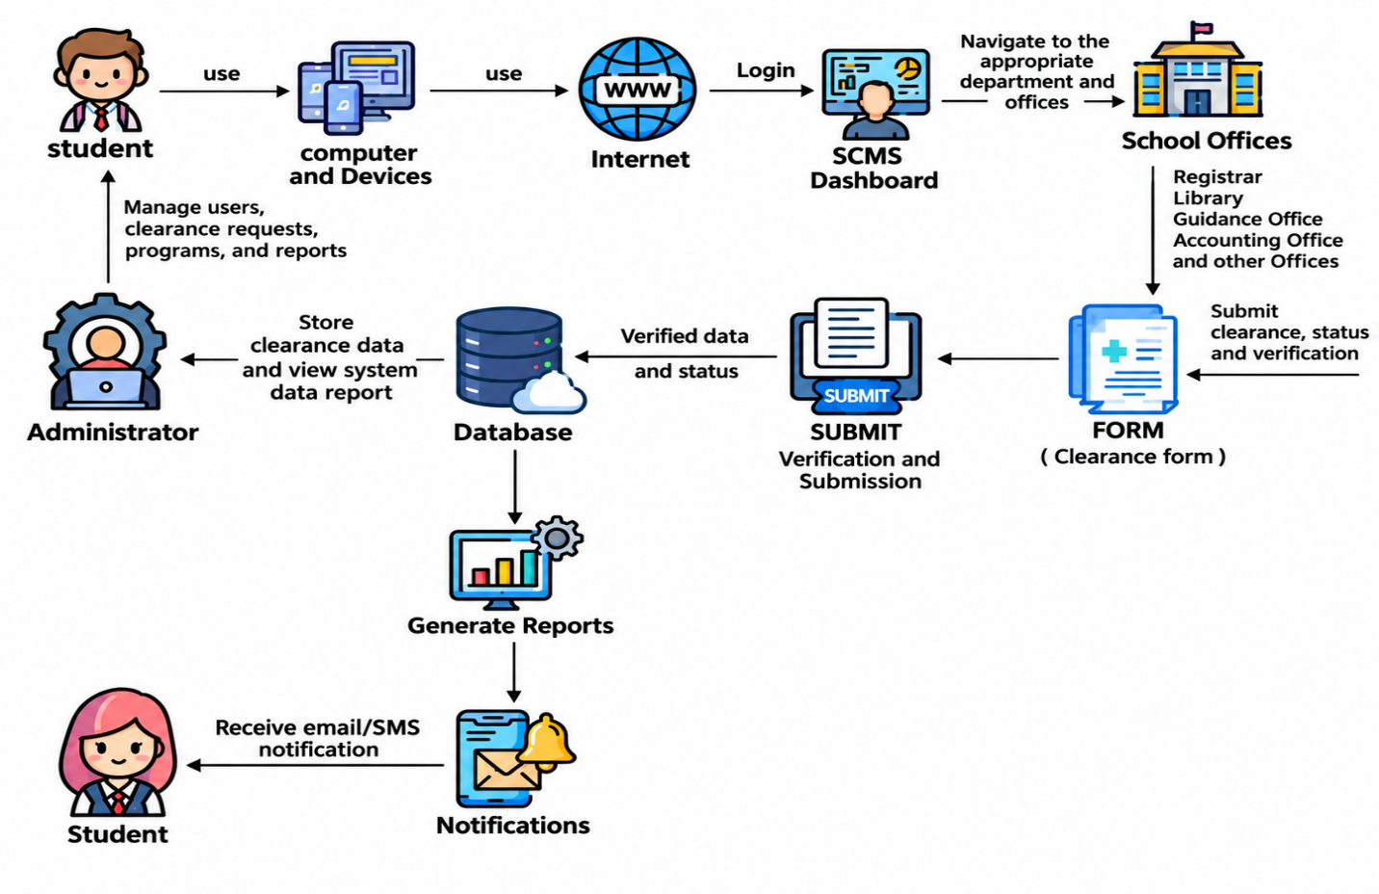

Figure 2. Project Detailed Design of the Web-Based Student Clearance Management System
Architectural Design (SDLC Waterfall Model)
The researchers used the SDLC Waterfall Model to develop the Student Clearance Management System. They first gathered the information on the system requirements provided by the client. During the design process, they designed the system based on the collected data to create detailed system specifications. In the development phase, they used Visual Studio as the code editor, utilizing PHP and JavaScript as the programming languages, while MySQL as the database. The fourth step was the testing, which ensured it worked properly before being deployed. Finally, they deployed the system. For the maintenance, they monitored the system’s errors/bugs and made necessary updates and improvements.
Waterfall Model
The Waterfall Model played a significant role in the development of the Student Clearance Management System because it provided a structured and systematic approach throughout the project. Its sequential phases, which are planning, requirements analysis, system design, development, testing, deployment, and maintenance, allowed the researchers to complete each phase before moving to the next. This approach helped the team clearly identify the needs of students, faculty, and school offices involved in the clearance process. During the design and development phases, the researchers focused on creating essential features such as student clearance requests, office approvals, status tracking, and report generation. The testing phase ensured that the system functioned accurately and minimized errors before deployment. By following the Waterfall Model, the researchers were able to develop a reliable and organized system that improves the efficiency of the student clearance process while providing proper documentation for future maintenance and enhancements. Furthermore, the model helped maintain clear project documentation and defined responsibilities for each development phase. This systematic process allowed the researchers to monitor the progress of the system, identify potential problems early, and ensure that the final system met the established requirements and objectives.
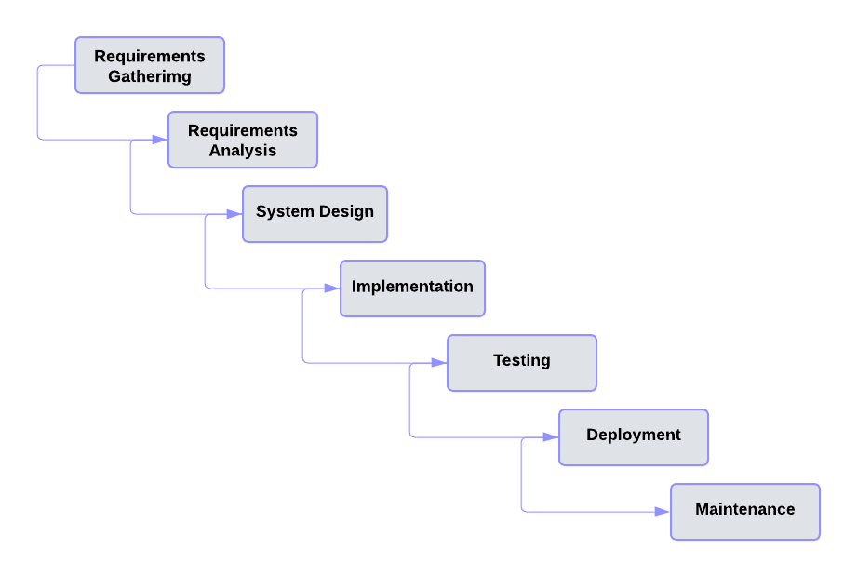

Figure 3. Waterfall Model

The development process using a waterfall model involved the following phase:
Requirements Gathering. The first phase involved collecting and documenting the system requirements by understanding the needs of the school administrators, faculty, staff, and students. Requirements gathering was an essential part of developing the Student Clearance Management System because it helped identify the existing challenges in the manual clearance process, such as delays, lost records, and difficulty in tracking clearance status. This phase also defined the system's key functionalities, including online clearance requests, office approvals, status tracking, and report generation. Properly gathered requirements ensured that the system addressed the users' needs, established a clear project scope, minimized misunderstandings, and provided a strong foundation for the design and
development of the system.
Requirements Analysis
Requirement analysis was the first and important phase in developing the Student Clearance Management System. During this phase, the researchers reviewed the information gathered from students, faculty, and school offices to understand their needs and the problems they experienced with the current clearance process. The researchers identified the main requirements and features needed for the system, such as online clearance requests, office verification and approval, clearance status tracking, notifications, user account management, and report generation. The different roles of students, office signatories, and administrators were also considered to determine their proper access and functions in the system. The gathered requirements were then organized and documented to serve as a guide for the next stages of development. This analysis helped the researchers design a system that is organized, easy to use, and able to improve the clearance process by reducing manual work, delays, and unnecessary office visits.

Table 1. Software Requirements of the Student Clearance Management (SCM) System
Software Requirements | Details | Description
Front-end | - HTML/CSS  - JavaScript | - Used for organizing and designing web pages  - Used to implement interactive functionalities.
Back-end | - Server-Side Language | - PHP: Open-source server-side scripting language for web development.
 | - Database | - Relational Databases: MySQL
Integrated Development Environment | - Visual Studio Code | - Provides support for multiple programming languages and frameworks via extensions

Table 1 presents the software requirements needed for the Student Clearance Management System. The system is designed to support the functions of students, school offices, and administrators throughout the clearance process. Students can submit clearance requests, monitor the status of their clearances, and receive notifications regarding pending or completed approvals. School offices are provided with features to review, approve, or reject clearance requests, while administrators can manage user accounts, monitor transactions, generate reports, and maintain the overall system.
The technical setup of the system consists of a web-based application developed using HTML, CSS, and JavaScript for the user interface, with PHP handling the server-side operations. MySQL serves as the database management system for storing and retrieving student and clearance records securely. The system was developed using Visual Studio Code, which provided an efficient environment for coding, debugging, and managing the project's development.
Table 2. Hardware Requirements of the Student Clearance Management (SCM) System
Hardware Requirements | Details | Description
Administrator Computer (Local Server) | Processor | - Intel Core i3/Ryzen 3 or higher
 | RAM | - 8 GB or higher
 | Storage | - 256 GB SSD or higher
 | Operating System | - Windows 10/11
Office Workstations | Processor | - Intel Core i3/Ryzen 3 or higher
 | RAM | - 4 GB or higher
 | Storage | - 128 GB SSD or higher
 | Network | - Local Area Network (LAN) or Stable Wi-Fi Connection
Student Devices | Desktop, Laptop, or Mobile Device | - Any device with a modern web browser and internet connection
Network Equipment | Router/Switch | - Provides network connectivity within the school campus
Power Backup | Uninterruptible Power Supply (UPS) | - Recommended to prevent data loss during power interruptions on the administrator's computer

Table 2 presents the hardware requirements needed for the Student Clearance Management System to operate efficiently within the school. Since the system is deployed locally, a dedicated enterprise server is not required. Instead, the administrator's computer serves as the local host for the application and database. School offices can access the system using desktop or laptop computers connected through the school's local network or a stable Wi-Fi connection, while students can use any device with a web browser to access the system. A reliable network connection and an Uninterruptible Power Supply (UPS) are recommended to ensure continuous operation and prevent data loss during unexpected power interruptions.
System Design. During this phase, the researchers developed the architectural design and detailed specifications of the Student Clearance Management System based on the gathered and analyzed requirements. This included designing the system architecture, database structure, user interfaces, system modules, and the flow of data between students, school offices, and administrators. System design was essential because it established how the system would process clearance requests, manage approvals, track clearance status, and generate reports. A well-designed system ensured a user-friendly interface, secure data management, efficient workflow, and reliable performance while providing flexibility for future updates and enhancements. Proper system design also improved the overall user experience and supported the system's long-term maintainability.

Hierarchical Input-Process-Output (HIPO)
The Hierarchical Input-Process-Output (HIPO) model is a structured system design tool used to illustrate the functions and operations of a system in a hierarchical manner. It breaks the system into different modules by identifying the inputs, processes, and outputs at each level, making the system easier to understand and document. In the development of the Student Clearance Management System, the HIPO model helped the researchers visualize the flow of information between students, school offices, and administrators. It showed how user inputs, such as clearance requests and office approvals, were processed by the system to produce outputs like clearance status updates, notifications, and reports. The HIPO model served as a guide during the design phase by providing a clear representation of the system's structure, improving communication among the researchers, and supporting the development of an organized and efficient system. It also helped identify the specific functions of each module and how they were connected to one another. Through this model, the researchers could clearly understand the sequence of activities involved in the clearance process. It supported the proper organization of system features, reduced confusion during development, and helped ensure that each process produced the expected result. This made the system easier to develop, test, maintain, and improve.

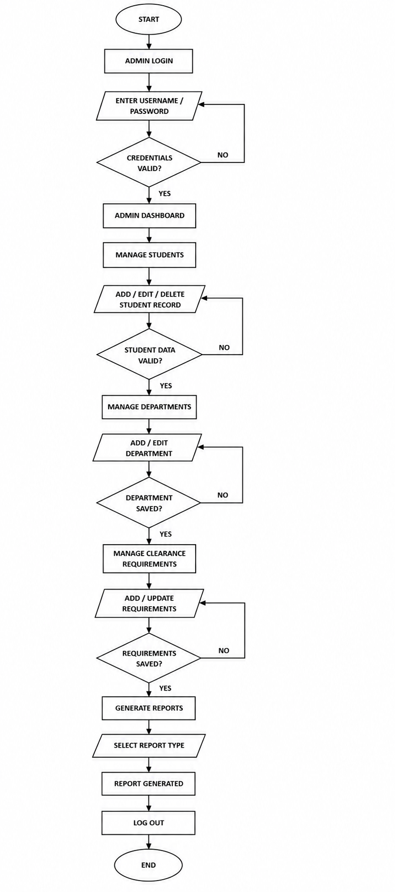

Figur

Figure 4. Hierarchical Input Process Output (HIPO) of Admin.
Figure 4 illustrates the Hierarchical Input-Process-Output (HIPO) model for the Admin Module of the Student Clearance Management System. The model presents the structured flow of administrative functions within the system. After successfully logging into the system, the administrator gains access to the Admin Dashboard, which serves as the central interface for managing system operations. The administrator can manage student records by adding, editing, or deleting student information, with validation ensuring that all required fields are correctly completed before the records are saved to the database. The admin can also manage departments or offices by creating, updating, or modifying office information used in the clearance process.
In addition, the administrator is responsible for managing clearance requirements by adding or updating the requirements that students must satisfy before clearance approval. Each management function includes validation procedures to ensure the accuracy and completeness of the data before it is stored. Furthermore, the administrator can generate reports by selecting a specific report type, allowing the system to produce updated clearance reports for monitoring and documentation purposes. Finally, the administrator may securely log out of the system after completing all administrative tasks. The HIPO model demonstrates a well-defined Input-Process-Output structure that promotes data accuracy, efficient system administration, and effective management of the Student Clearance Management System.

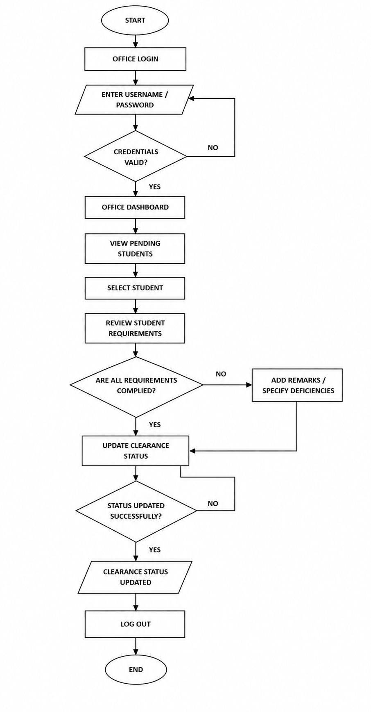

Figure 5. Hierarchical Input Process Output (HIPO) of school offices.
Figure 5 presents the Hierarchical Input-Process-Output (HIPO) model for the School Offices Module of the Student Clearance Management System. The diagram illustrates the workflow performed by authorized personnel from participating school offices, such as the Registrar, Accounting, Library, Guidance Office, Clinic, Property Custodian, and other offices responsible for student clearance. The process begins when an office personnel logs into the system and accesses the Office Dashboard. From the dashboard, the user can view the list of students with pending clearance requests and select a specific student for evaluation. The system then displays the student's clearance records and office-specific obligations for verification. If the student has outstanding requirements, the office personnel may enter remarks or indicate the deficiencies that must be completed before clearance can be granted. Once all office requirements have been satisfied, the personnel approve the student's clearance and updates the clearance status. Before the changes are saved, the system validates the submitted information to ensure that all required data has been completed correctly. If validation fails, the user is prompted to correct the information before resubmitting. After successful validation, the updated clearance status is saved and immediately reflected in the student's clearance record, allowing both the student and the administrator to monitor the progress of the clearance process. Finally, the office personnel may securely log out of the system after completing the transaction. This HIPO model demonstrates a structured Input-Process-Output workflow that enables school offices to efficiently verify student obligations, record clearance decisions, update clearance statuses accurately, and maintain a reliable and organized clearance management process within the Student Clearance Management System.
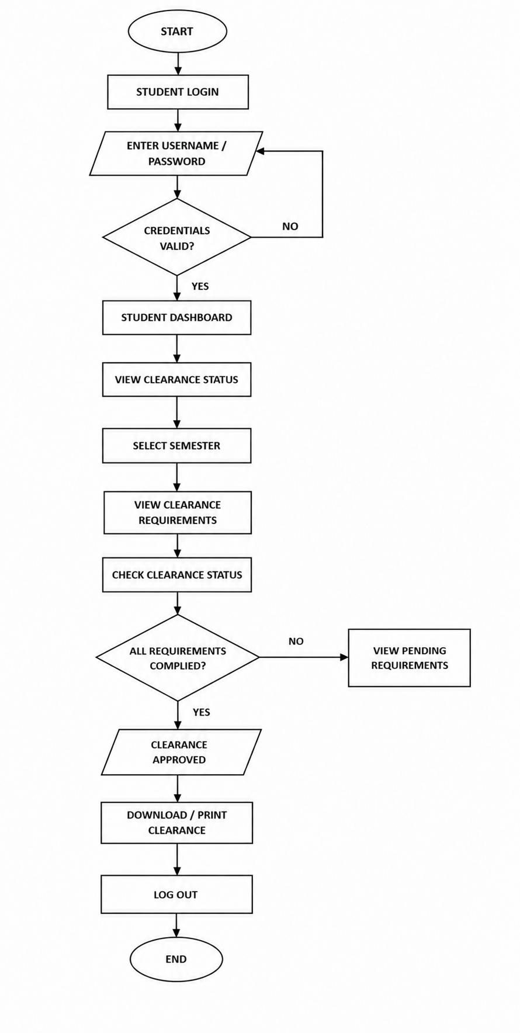

Figure 6. Hierarchical Input Process Output (HIPO) of Students.

Figure 6 illustrates the Hierarchical Input-Process-Output (HIPO) model for the Student Module of the Student Clearance Management System. The diagram presents the workflow followed by students as end-users of the system throughout the clearance process. The process begins when a student logs into the system using valid credentials to access the Student Dashboard. From the dashboard, the student can view their current clearance status, select the applicable semester, and access the list of clearance requirements assigned by the different school offices. The system displays the status of each office, allowing the student to monitor whether the required clearances have been completed or if there are pending obligations that must still be fulfilled. If outstanding requirements exist, the student can review the pending remarks or deficiencies provided by the respective school offices and complete the necessary requirements before checking the clearance status again. Once all participating offices have approved the student's clearance, the system updates the overall clearance status and allows the student to view, download, or print the completed clearance as proof of completion. Finally, the student may securely log out of the system after completing the transaction. This HIPO model demonstrates a structured Input-Process-Output workflow that enables students to efficiently monitor their clearance progress, verify office approvals, and obtain their completed clearance while ensuring transparency, accessibility, and accuracy throughout the Student Clearance Management System.

Data Flow Diagram of Student Clearance Management System
This data flow diagram illustrates the Student Clearance Management System, which is designed for students, office signatories, and administrators to provide a simple and organized clearance process through a structured multi-office approval workflow. The process begins with the Log In (1.0) module, where students, office signatories, and administrators enter their login credentials. The system authenticates these credentials and stores the user information in the user’s table. After logging in, students can submit and monitor their clearance requests through the Manage Clearance Request (2.0) module, with all request information saved in the clearance_ requests table. The Office Requirement Submission (3.0) process allows each office, such as the Registrar, Library, Guidance, Accounting, and other authorized offices, to verify whether students have completed their required obligations. The results of these evaluations are recorded in the clearance_ items table. Once all office requirements have been evaluated, the request is forwarded to the Clearance Approval (4.0) module, where the Registrar, Dean, or Administrator reviews and either approves or rejects the student's clearance. If approved, students can proceed to the Download Clearance Certificate (5.0) module to generate and download their official clearance certificate. The Notifications (6.0) module keeps students informed by sending updates about pending requirements, office approvals, and the overall status of their clearance. These notifications are stored in the notifications table. Administrators also have access to additional system functions, allowing them to manage clearance requirements, approve or reject office submissions, update or override clearance records when necessary, and maintain reference data through the Manage Reference Data (7.0) module. This includes updating office lists, requirement types, course offerings, and semester records stored in the office_ list, requirement_ types, course_ list, and semester_ list tables. Finally, completed clearance records are transferred to the Archive Cleared Records (8.0) module, where they are stored in the clearance_ archive for future reference and institutional record-keeping. The system also promotes better coordination among different offices by providing a centralized platform for processing and monitoring clearance requirements. Each authorized user can access information based on their assigned role, helping maintain data security and accountability. The organized flow of information reduces the need for manual processing, minimizes delays, and makes it easier to track the progress of each clearance request. It also provides administrators with reliable records that can be reviewed when resolving concerns or verifying completed transactions. Overall, the system helps make the student clearance process more efficient by providing a centralized workflow, timely notifications, organized record management, and a structured approval process across different offices.
In addition, the system ensures that clearance information is properly organized and accessible to authorized personnel. It supports faster communication between students and offices by providing updated clearance statuses and notifications. This allows students to identify pending requirements and take appropriate action without repeatedly visiting different offices. The system also strengthens accountability by maintaining records of submissions, verifications, approvals, and completed clearances for easier monitoring and future reference.
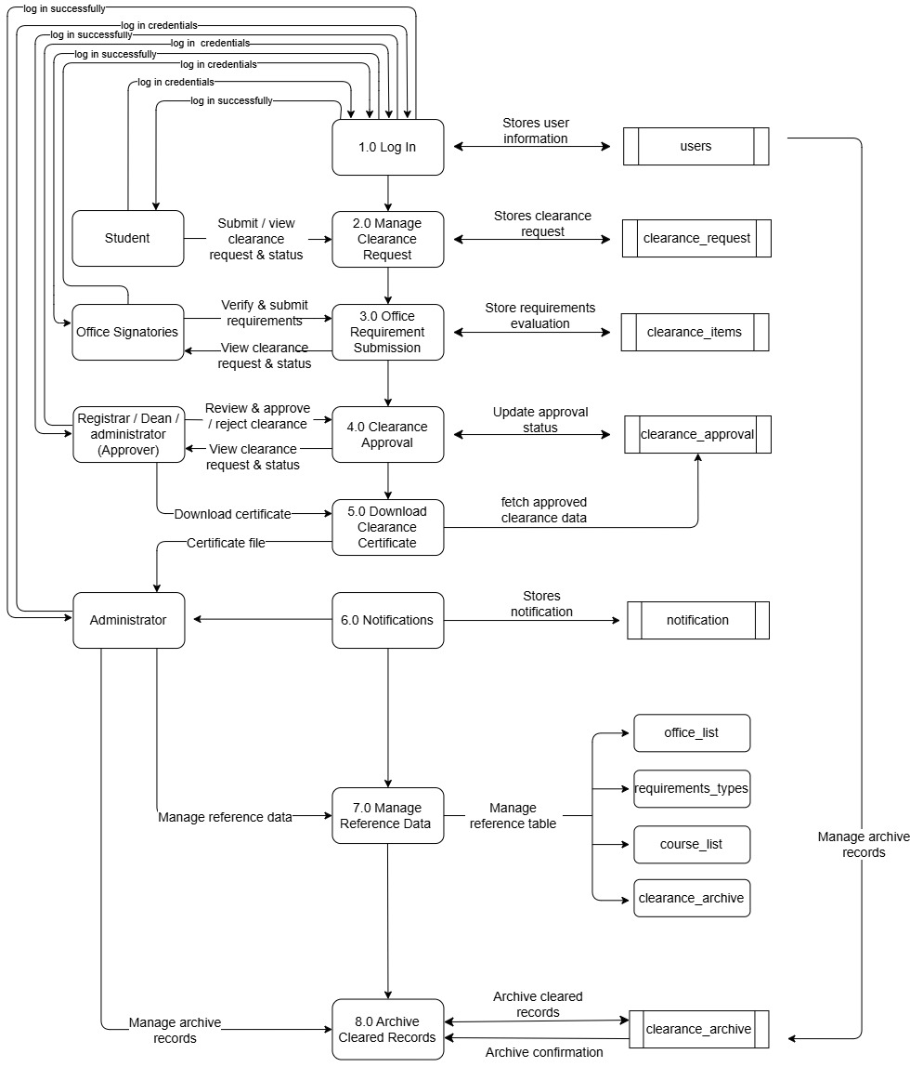
Figure 8. Data flow Diagram of Student Clearance Management System.

Figure 8. The Student Clearance Management System is developed to streamline the submission, verification, approval, issuance, and archiving of student clearance records, involving users such as students, office signatories, the Registrar/Dean, and administrators. All users begin by logging in through the 1.0 Log In process, which verifies their credentials and stores them in the user table. Once authenticated, students can access the 2.0 Manage Clearance Request module to submit and monitor their clearance requests, with the request information stored in the clearance requests table. Office signatories from different departments, such as the Registrar, Library, Guidance, Accounting, and other authorized offices, are responsible for verifying student requirements through the 3.0 Office Requirement Submission process, where the status of each requirement is recorded in the clearance items table. These submissions are then reviewed through the 4.0 Clearance Approval process, where the Registrar, Dean, or Administrator has the authority to approve or reject the student's overall clearance, updating its status in the same records. Once approved, students can access the 5.0 Download Clearance Certificate module to generate and download their official clearance certificate. The approval or rejection results, including updates on pending office requirements, are communicated to students through the 6.0 Notifications module, which stores notification data in the notifications table and tracks unread alerts. Administrators also have access to the 7.0 Manage Reference Data module, allowing them to maintain reference tables such as office_ list, requirement_ types, course_ list, and semester_ list, ensuring consistency and accuracy in the clearance process. Additionally, completed or inactive clearance records are processed through the 8.0 Archive Cleared Records module and stored in the clearance archive database for future reference and institutional record-keeping. Overall, the system provides secure user access, a structured multi-office approval workflow, centralized clearance management, timely notifications, and organized record archiving, ensuring efficiency, accountability, and transparency throughout the student clearance process.

Entity Relationship Diagram of Student Clearance Management System.
Figure 9. The Entity-Relationship Diagram (ERD) illustrates the logical structure of the Student Clearance Management System, emphasizing the relationships among the key data entities used for managing student clearance requests, office verification, approval, and record archiving. At the core of the design is the clearance_ requests table, which stores detailed information about each student's clearance request, including its status, submission details, and approval progress. This central table is normalized through multiple foreign key connections to reference tables such as office_ list, requirement_ types, course_ list, and semester_ list, enabling standardized data entry and consistent system operations. The users table stores user information for students, office signatories, and administrators and is linked to the clearance_ requests table, ensuring accountability and traceability of all clearance transactions. User interactions with the system are managed through the clearance_ items and notifications tables. The clearance_ items table records the verification status of each office requirement for every student, while the notifications table stores system-generated alerts regarding pending requirements, approval updates, and completed clearances. Both tables maintain relationships with the users and clearance_ requests tables through foreign keys. For historical record management, the clearance_ archive table preserves completed clearance records without affecting the active clearance process.
The ERD also provides a structured representation of how information is connected throughout the system. The relationships between the tables allow the system to retrieve accurate information whenever a clearance request is submitted, verified, approved, or archived. The use of primary and foreign keys helps maintain data integrity and prevents unrelated or duplicate records from being created. It also allows authorized users to easily identify the student associated with a particular clearance request and determine which offices have completed or still need to verify their requirements. The database structure supports the different roles of students, office signatories, and administrators by providing appropriate access to the information needed for their responsibilities. In addition, the organized relationships make it easier to generate reports, monitor clearance progress, and review previous transactions. Overall, the ERD serves as an important guide for developing the database and ensures that the system can efficiently manage, store, retrieve, and maintain clearance information.
The ERD helps ensure that all important clearance-related information is properly organized within the database. This structured design improves data accessibility and supports reliable system operations. It also provides a clear basis for future system improvements, allowing additional features and records to be integrated without significantly affecting the existing database structure.
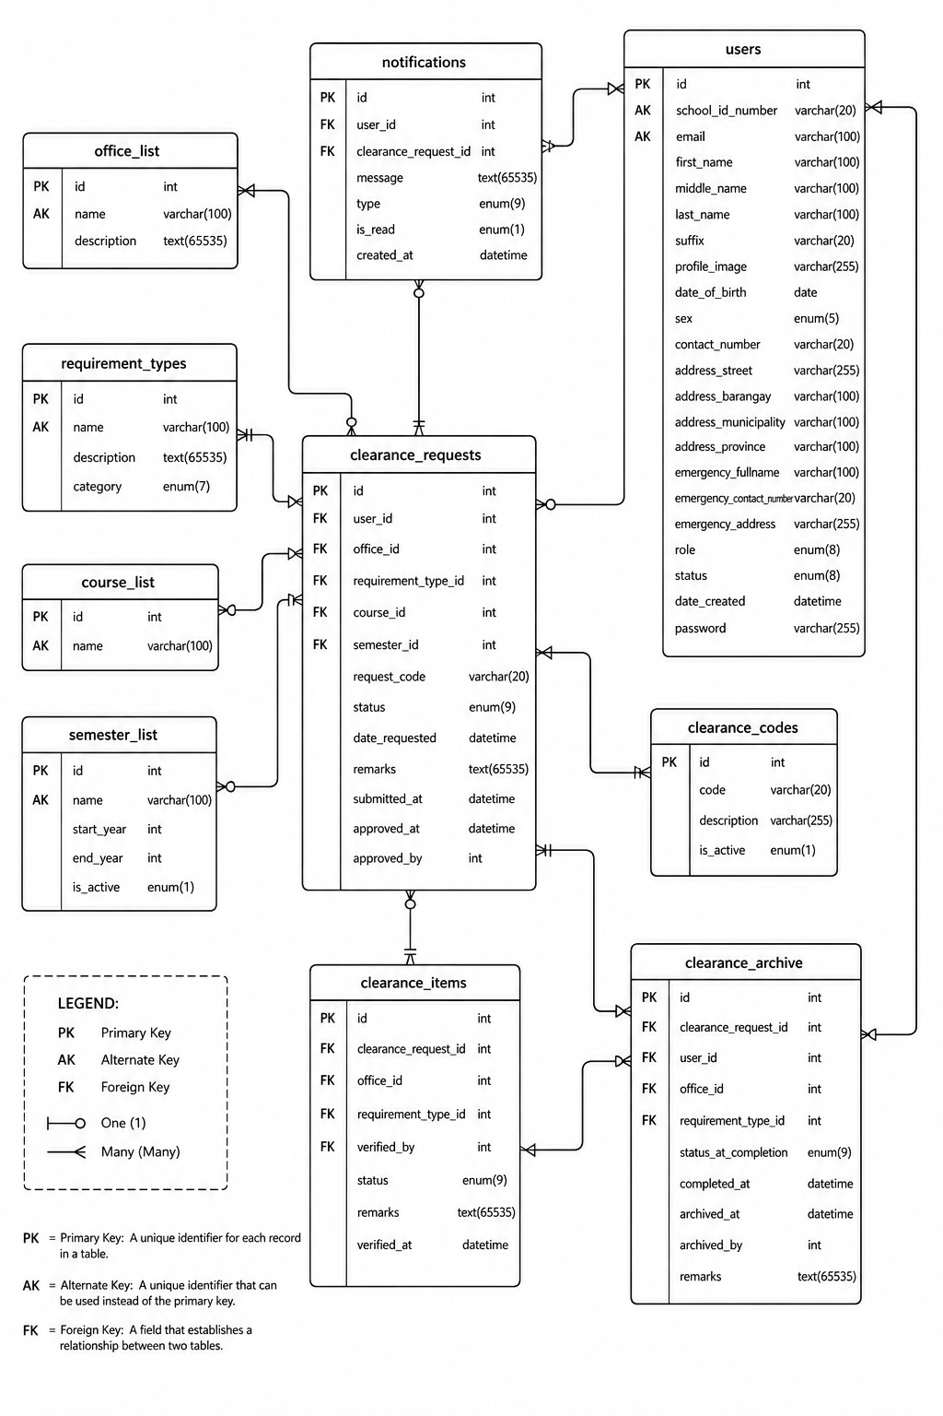
Figure 9. Entity Relationship Diagram of Student Clearance Management System.
database. While most foreign key relationships are implemented using ID-based references, the database structure is designed to support future enhancements that further strengthen referential integrity and improve overall system performance. Overall, the ERD presents a modular, scalable, and well-structured relational database architecture that supports efficient clearance processing, secure data management, and reliable institutional record keeping.
System Implementation. The implementation phase of the Student Clearance Management System involved the coding, development, and integration of the system based on the approved system design and specifications. During this phase, the designed models and system requirements were translated into a fully functional web-based application that automated the student clearance process. The implementation focused on developing core modules such as user authentication, clearance request processing, department approval, status monitoring, notification management, and user profile management. Different user roles, including students, office signatories, and administrators, were implemented to ensure that each user had appropriate access and responsibilities within the system.
The implementation also involved integrating the various system modules to ensure seamless communication and efficient data flow throughout the clearance process. Extensive testing was conducted to evaluate the system's functionality, performance, reliability, security, and usability. Necessary revisions and optimizations were applied based on the testing results to improve system efficiency and user experience. Effective implementation practices contributed to the successful development of a reliable, secure, and user-friendly Student Clearance Management System that streamlined clearance processing, minimized paperwork, improved transaction transparency, and supported timely completion of student clearance requirements.
Visual Studio Code served as the primary source code editor during the development of the Student Clearance Management System. It provided essential development features such as syntax highlighting, intelligent code completion, debugging tools, and extension support that improved coding efficiency and software development. Visual Studio Code also integrated seamlessly with version control systems and other development tools, enabling efficient implementation, testing, and maintenance of the system.
HTML (Hypertext Markup Language) was utilized to create the structural foundation of the Student Clearance Management System's web pages. It was responsible for organizing and displaying the system's content, including login forms, dashboards, clearance records, user profiles, notifications, and administrative interfaces. HTML ensured that the system presented information in a structured and accessible manner, providing users with an intuitive and organized interface.
CSS (Cascading Style Sheets) was used to enhance the visual appearance and responsiveness of the Student Clearance Management System. It controlled the layout, colors, typography, spacing, and overall presentation of the web pages, creating a clean, professional, and user-friendly interface. CSS also enabled the system to adapt effectively to different screen sizes and devices, ensuring accessibility and usability across various platforms.
JavaScript was implemented to provide interactive and dynamic functionality within the Student Clearance Management System. It enhanced the user experience by enabling real-time form validation, dynamic content updates, responsive navigation, confirmation dialogs, asynchronous data processing, and interactive user interfaces without requiring constant page reloads. JavaScript also improved system responsiveness and contributed to a smoother and more efficient workflow for users.
PHP (Hypertext Preprocessor) served as the primary server-side scripting language for the Student Clearance Management System. It handled the system's core business logic, including user authentication, session management, clearance request processing, department approval workflows, notification generation, and secure communication with the database. PHP also validated user inputs, enforced access control based on user roles, and processed transactions efficiently. Its seamless integration with HTML, CSS, JavaScript, and MySQL enabled the development of a secure, reliable, and fully functional web-based clearance management system.
MySQL was utilized as the relational database management system for storing and managing all system data. It maintained records related to students, office signatories, administrators, clearance requests, approval statuses, notifications, and user accounts. MySQL ensured data integrity, consistency, and security while providing fast and efficient data retrieval through optimized indexing and query processing. Its scalability and reliability allowed the Student Clearance Management System to efficiently handle increasing volumes of records and users while maintaining excellent system performance.
Calendar of Activities
The development of the Student Clearance Management System was not accomplished through a single activity but through a series of organized and systematic phases, each contributing to the successful completion of the project. The project followed the Waterfall Software Development Model, which provided a structured and sequential approach to system development. Each phase requirements gathering, system analysis, system design, implementation, testing, deployment, and documentation was completed before proceeding to the next stage, ensuring that project objectives and requirements were thoroughly addressed.
The calendar of activities served as a visual representation of the project's timeline, outlining the specific tasks and milestones accomplished during each phase of development. It enabled the researchers to effectively plan, monitor, and evaluate the progress of the project while ensuring that all activities were completed within the established schedule. This systematic approach promoted efficient project management, proper resource allocation, timely completion of deliverables, and the successful implementation of the Student Clearance Management System according to the project's objectives and institutional requirements.

Requirements Gathering and Requirements Analysis.
Requirements gathering and requirements analysis were essential phases in the development of the Student Clearance Management System, as they involved identifying and analyzing the needs and expectations of students, office signatories, and administrators. During this phase, the researchers examined the existing clearance process and gathered the system's functional and non-functional requirements, including user authentication, clearance processing, status tracking, notifications, security, and usability. The information collected served as the foundation for designing and developing a system that streamlined the clearance process, improved efficiency, reduced manual work, and met the institution's operational requirements.
Systems Design. This phase involved designing the overall structure of the Student Clearance Management System, including the user interface, database, system workflow, and user access for students, office signatories, and administrators. It also focused on implementing security measures and defining the system architecture to ensure efficient, reliable, and secure clearance processing. The system design served as the blueprint for the development of the system based on the identified requirements.
Implementation. This phase involved developing the Student Clearance Management System based on the approved system design. The researchers created the database, developed the system modules, integrated the system components, and conducted testing to ensure that all features functioned correctly. The project followed the Waterfall model, progressing through Requirements Gathering, Requirements Analysis, Systems Design, and Implementation from January to May 2025, while Documentation and Maintenance were carried out throughout the development process to support system quality and future improvements.

Table 3. Calendar of Activities from January to May 2025
Activities | 2025
Activities | July |  |  |  |  |  | August |  |  |  |  |  |  |  | September |  |  |  |  |  |  |  | October |  |  |  |  |  |  |  |  | November
Activities | 1 | 2 |  | 3 |  | 4 |  | 1 |  | 2 |  | 3 |  | 4 | 1 |  | 2 |  | 3 |  | 4 | 1 |  |  |  |  | 2 |  | 3 |  | 4 |  | 1 |  | 2 |  | 3 |  | 4
Requirements Gathering
Requirements Analysis
System Design
Research Proposal
Implementation
Testing
Deployment
Final Defense
Documentation and Maintenance

Testing. After the implementation phase, the Student Clearance Management System underwent several levels of testing to ensure its functionality, reliability, and overall performance. These included unit testing to evaluate individual system components, integration testing to verify the interaction between modules, system testing to validate the complete system, and user acceptance testing to ensure that the system met the requirements of students, office signatories, and administrators. Through these testing activities, errors were identified and corrected, system performance was improved, and the researchers ensured that the system was secure, accurate, user-friendly, and capable of supporting an efficient and reliable student clearance process.

Table 4. Calendar of Activities from June to October 2025
Activities | 2024
Activities | June |  |  |  |  |  | July |  |  |  |  |  |  |  | August |  |  |  |  |  |  |  | September |  |  |  |  |  |  |  | October
Activities | 1 | 2 |  | 3 |  | 4 |  | 1 |  | 2 |  | 3 |  | 4 | 1 |  | 2 |  | 3 |  | 4 | 1 |  |  | 2 |  | 3 |  | 4 | 1 |  | 2 |  | 3 |  | 4
Requirements Gathering
Requirements Analysis
System Design
Research Proposal
Implementation
Testing
Deployment
Final Defense
Documentation and Maintenance

Deployment. After successful testing, the Student Clearance Management System was deployed to the production environment, making it accessible to students, office signatories, and administrators. This phase involved system installation, configuration, and final validation to ensure that all modules functioned correctly in the live environment. User orientation and initial support were also provided to facilitate smooth adoption and effective use of the system.
Maintenance. The maintenance phase involved providing continuous support to ensure the reliable operation of the Student Clearance Management System. This included fixing system errors, improving existing features, updating security measures, optimizing database performance, and responding to user feedback. Regular maintenance ensured that the system remained secure, efficient, and capable of meeting the institution's evolving clearance management requirements.
Research Environment
Christ the King College de Maranding, Inc. is strategically located in the southern part of the Municipality of Lala, along the National Highway connecting Iligan City and Pagadian City. The Student Clearance Management System was developed specifically for the institution to streamline the student clearance process. The system is designed for use by students, office signatories, and administrators, enabling efficient clearance processing, status monitoring, and record management. By automating the traditional clearance procedure, the system improves efficiency, reduces paperwork, and enhances the overall management of student clearances within the institution.
Figure 10. Environment of the Study
Research Respondents
The respondents of this study consisted of students, office signatories, administrators, and IT professionals of Christ the King College de Maranding, Inc., who played significant roles in evaluating the proposed Student Clearance Management System. These participants provided valuable information regarding the existing clearance process, the challenges encountered in manual clearance transactions, and the effectiveness of the proposed system in improving the efficiency, accuracy, and security of clearance processing. Their feedback was essential in assessing the system's functionality, usability, reliability, and overall acceptability before its implementation.
To obtain representative data from the different user groups within the institution, the researchers employed cluster sampling. This sampling technique enabled the selection of respondents from various departments and offices involved in the student clearance process, ensuring that each group was adequately represented in the study. By gathering responses from diverse participants, the researchers were able to conduct a comprehensive evaluation of the system and formulate valid conclusions regarding its performance and effectiveness. The distribution of the respondents is presented in Table 5

Table 5. Distribution of the Respondents
Data Gathering Procedures
 | Frequency | Percent
School Administrators | ? | ?
Teacher | ? | ?
Student | ? | ?
IT Professionals | ? | ?
Total | ? | ?

The researchers began by gathering relevant literature, references, and related studies to support the development of the Student Clearance Management System. They conducted extensive research on existing student clearance systems and related information management systems to identify best practices, system features, and effective solutions applicable to the institution's clearance process. Prior to conducting the study, the researchers formally requested approval from the research adviser and the school administration, including the School President, Executive Vice President, Vice President for Research, Vice President for Academic Affairs, Department Dean, and the offices involved in the student clearance process. Upon receiving the necessary approvals, the researchers proceeded with the data-gathering activities. Interviews, consultations, and surveys were conducted with students, office signatories, administrators, and IT professionals to collect accurate and relevant information regarding the existing clearance procedures, identify current challenges, and gather recommendations that served as the basis for the design and development of the proposed Student Clearance Management System.
Statistical Treatment of the Data
The responses gathered from the respondents through the survey questionnaire were statistically analyzed to meet the objectives of the study and evaluate the Student Clearance Management System. Appropriate statistical tools were employed to ensure accurate interpretation and analysis of the collected data.
Frequency and Percentage. Frequency and percentage were used to describe the demographic profile of the respondents and summarize their responses to the survey questionnaire. Frequency refers to the number of times a particular response or category appears in the data set, while percentage represents the proportion of respondents selecting a particular response in relation to the total number of respondents. These statistical tools provided a clear picture of the distribution of responses and facilitated the interpretation of the collected data.
Frequency is the number of times a particular value or category occurs in a data set.
Percentage is a way of expressing a number as a fraction of 100. It is calculated by dividing the frequency of a value by the total number of values and then multiplying by 100.
Percentage = $\left(\frac{frequency}{total number of values}\right) x 100$
Weighted Mean. The weighted mean was used to determine the respondents' level of evaluation and acceptability of the Student Clearance Management System in terms of its functionality, usability, reliability, efficiency, and overall performance. This statistical tool assigns corresponding weights to each response and computes an average value that represents the respondents' overall assessment.
The weighted mean is an average where each value has a specific weight, reflecting its importance or frequency. The formula is:
Weighted Mean = $\frac{∑\left(w_{i}x_{i}\right)}{∑w_{i}}$
Where:
$x_{i}$ = individual rating or response value
$w_{i}$= weight assigned to each response
$Σ$ = summation of all values

References
Al-Kofahi, M., Hassan, H., & Mohamad, R. (2025). DeLone and McLean information systems success model: a literature review. International Journal of Business Information Systems, 48(4), 452–481. https://doi.org/10.1504/IJBIS.2025.145551
Bacongol, D. M. A., & Durango, D. B. (2025). International Journal of Open-Access, Interdisciplinary & New Educational Discoveries of ETCOR Educational Research Center (iJOINED ETCOR). 243–254.
Baijun, H. (2024). Impact of Digital Transformation on Higher Education Management: A Theoretical Analysis. Journal of Industry and Engineering Management, 2(3), 35–39. https://doi.org/10.62517/jiem.202403307
Bashiru, T., & Abass, A. (2026). Design and Development of a Workflow-Driven Online Student Clearance System for Seamless Multi-Departmental Integration. 3(1), 62–74. https://doi.org/10.5281/zenodo.18506360
Bingamawa, M. T., Putri, T. S., Pambayun, K. G., Hirzan, M., & Pratama, I. M. (2026). Double Diamond Approach to Design Web - based Library Clearance Management System for Graduation Requirements. 15, 2869–2890.
David, D. H. S., Ticsay, S. J. F., Lazaga, C. M. A., Miranda, K. P., & Castro, A. B. S. (2026). AUFlow: A Dynamic University-Wide Workflow System with Snapshot-Chain Verification for Document Approvals. In ICCSIT 2025 - Proceedings of the 2025 18th International Conference on Computer Science and Information Technology (Vol. 1, Number 1). Association for Computing Machinery. https://doi.org/10.1145/3783862.3783901
E. I., E., & I. R., B. (2024). Design and Implementation of a Robust Web-based Clearance System for Students in Nigerian Colleges of Education. British Journal of Computer, Networking and Information Technology, 7(2), 86–96. https://doi.org/10.52589/bjcnit-xtwilqmz
Essel, D. D., Techie-menson, H., Oppong, S. O., & Alakuu, A. (2023). Digitalising the Clearance Processes of Higher Education Institutions through the Design and Implementation of an Online Clearance System. 11(07), 42–58. https://doi.org/10.18535/ijsrm/v11i07.as01
Grepon, B. G. S., Migan, K., Gumonan, V. C., & Martinez, A. L. M. (2021). Designing and Implementing e-School Systems : An Information Systems Approach to School Management of a Community College in Northern Mindanao , Philippines Abstract Purpose – Colleges and Universities have been established to provide educational services. https://doi.org/10.25147/ijcsr.2017.001.1.74
Hasan, S. B., Nader Abdullah, Y., & Khalil Darwesh, M. (2023). Design and Implementation The digital transformation of the student clearance system for Soran University. Academic Journal of Nawroz University, 12(3), 252–261. https://doi.org/10.25007/ajnu.v12n3a1633
Jauculan, L. L., Patayon, U. B., Jauculan, L. L., & Patayon, U. B. (2024). ScienceDirect ScienceDirect Enhancing UX / UI : A Mixed-Approach Evaluation of a Web-Based Enhancing UX / UI : A Evaluation Student Clearance System at a State University in of the a Philippines Student Clearance System at a State University in the Philip. Procedia Computer Science, 234, 1061–1068. https://doi.org/10.1016/j.procs.2024.03.100
Miruthula, G. (2026). DESIGN OF A ROLE BASED ACCESS CONTROL SYSTEM FOR MULTI USER ENVIRONMENTS. 1–9.
O’dea, M., Zhou, X., Teng, D., Mundy, D., & Ishaya, T. (2025). Editorial: “Are Technology Acceptance Models still fit for purpose?” Journal of University Teaching and Learning Practice , 21(8). https://doi.org/10.53761/1bdbms32
Of, D., Payment, A. W. A., Portal, S., Joseph, U. M., Of, F., Sciences, N., Of, F., Award, T. H. E., & Bachelor, O. F. (2026). DEVELOPMENT OF A WEBHOOK-BASED AUTOMATED PAYMENT VERIFICATION AND DIGITAL RECEIPTING SYSTEM FOR GOUNI FULFILLMENT OF THE AWARD OF BACHELOR OF.
Paul, J., Dennis, C., Kacprzak, A., Curtis, L., Kunz, W. H., Liu, J., Petit, O., & Tyagi, S. (2024). Digital transformation : A multidisciplinary perspective and future research agenda. (January), 1–28. https://doi.org/10.1111/ijcs.13015
R. Choudhary, H. Tariq, N. R. Chaudhry, Maneha, & R. Awan. (2024). Streamlining Workflow Processes in Public Sector Universities: a Modeling and Simulation-Based Automation Solution. Pakistan Journal of Science, 76(01), 169–177. https://doi.org/10.57041/vol76iss01pp169-177
Sholefah, W. P., & Romadloni, N. T. (2026). Design and Development of a Web-Based Audit Clearance Letter Application System Using PHP Framework at the Karanganyar Inspectorate. 16(79), 275–286.
State, M., Autonomous, B., & Office, P. (2022). Secured Cotabato City State Polytechnic College Web-. 3(1), 61–66.

